**UNIVERSITY INSTITUTE OF COMPUTING**



**PROJECT REPORT**

**ON**

**RESTAURANT WEBSITE**

**SPICE OF WEBSITE**

Program Name: BCA

Subject Name/Code: Web Designing (24CAH-153)

Submitted to: Submitted by: Name: Manisha Nagpal Name: Chhavi Kamra

UID:24BCA10200

Section:24BCA8-B

**Abstract**

**This project is a responsive restaurant website designed using HTML, CSS, and JavaScript.**

**The website aims to provide users with an interactive and user-friendly platform to explore**

**the restaurant’s menu, make table reservations, view opening hours, and get contact information.**

**Key features include a modern homepage, an image gallery, online reservation form, and**

**contact section. The site is optimized for both desktop and mobile devices, ensuring**

**a smooth browsing experience for all users.**

**Code**

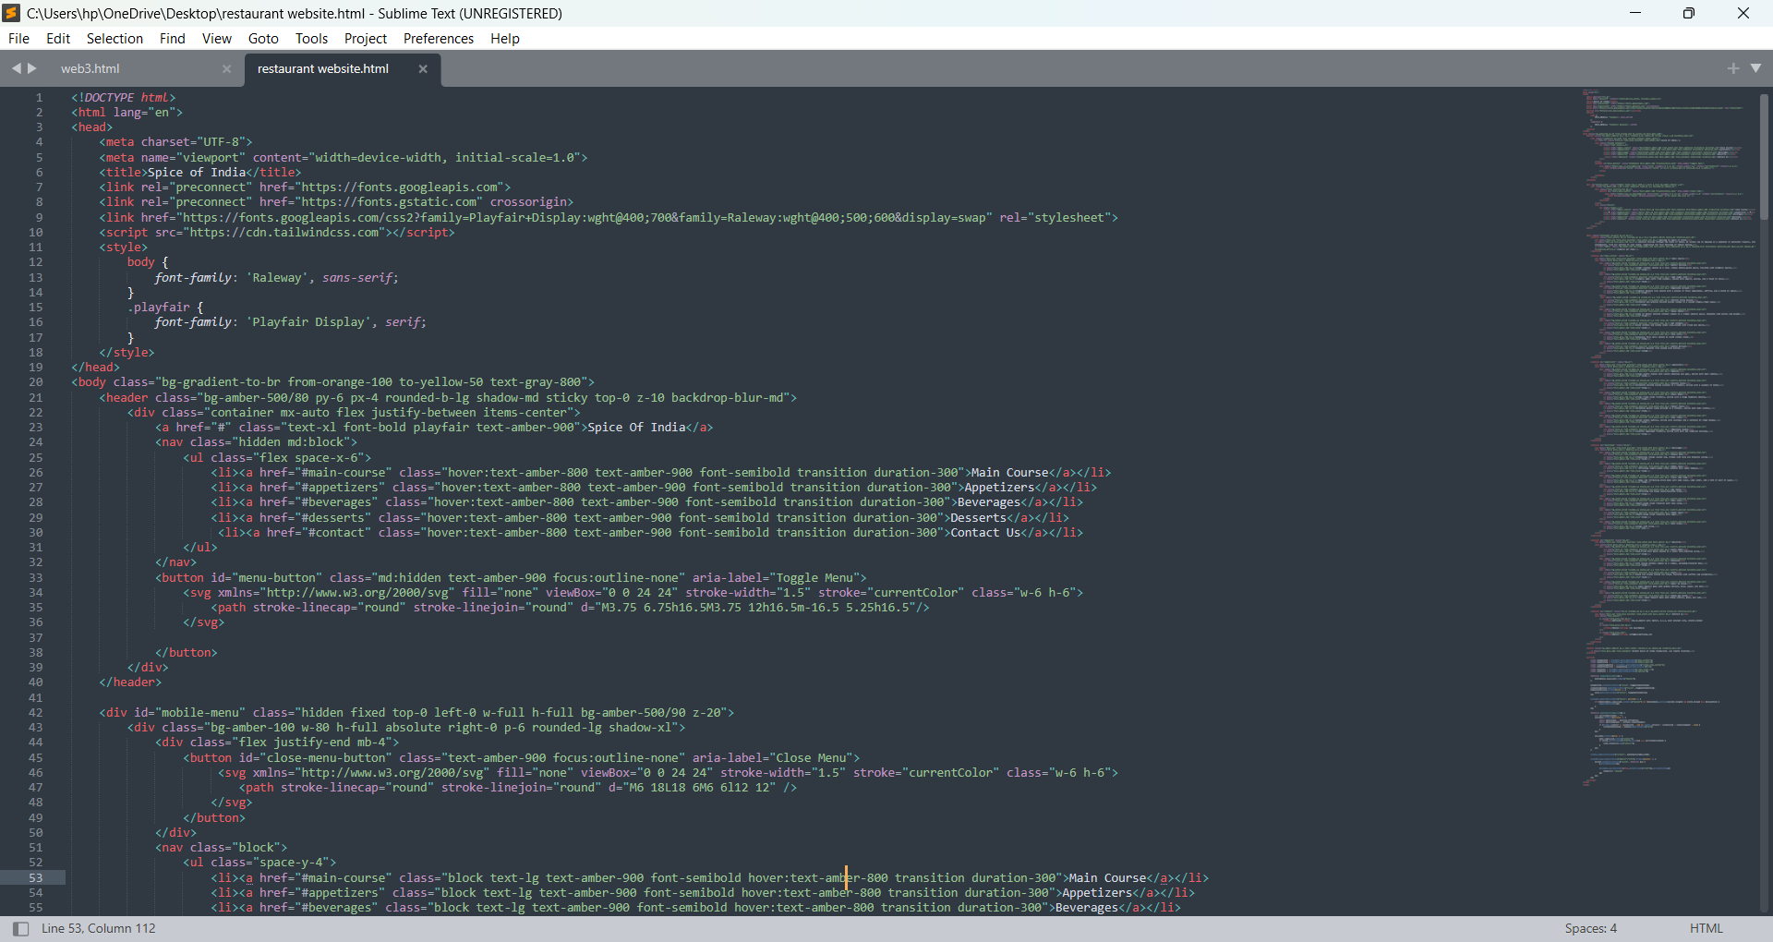

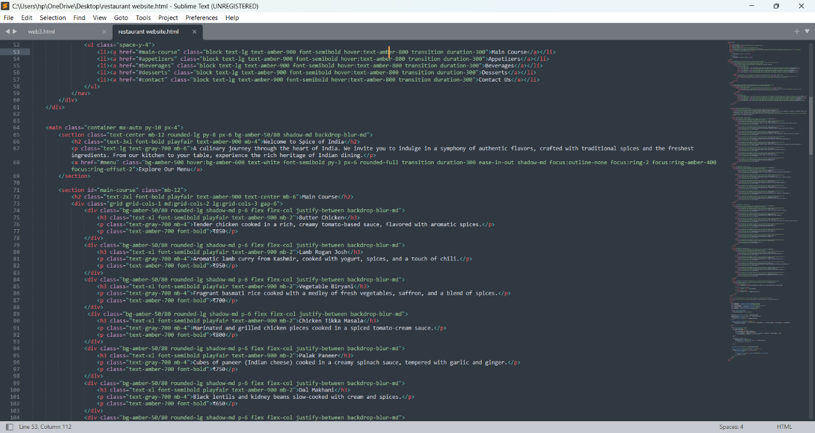

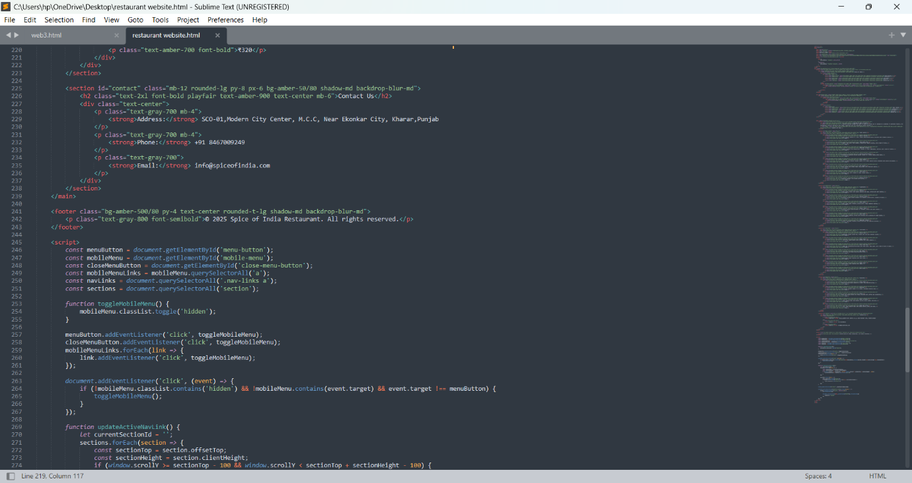

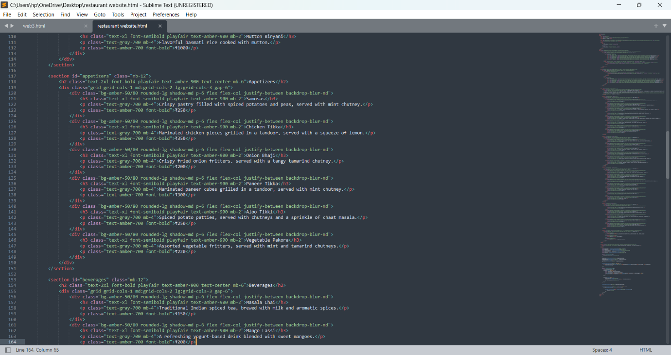

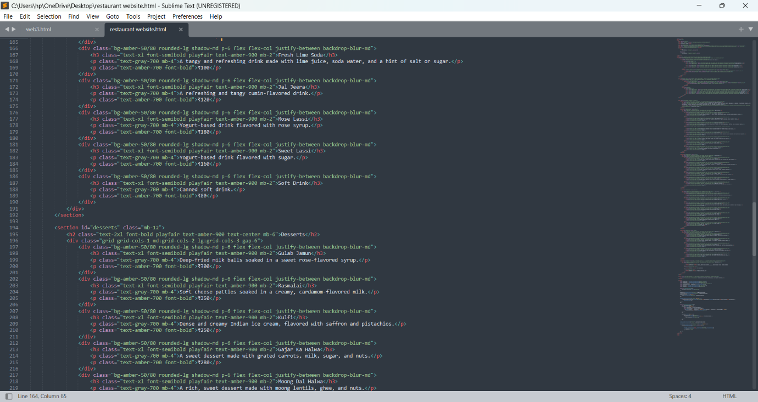

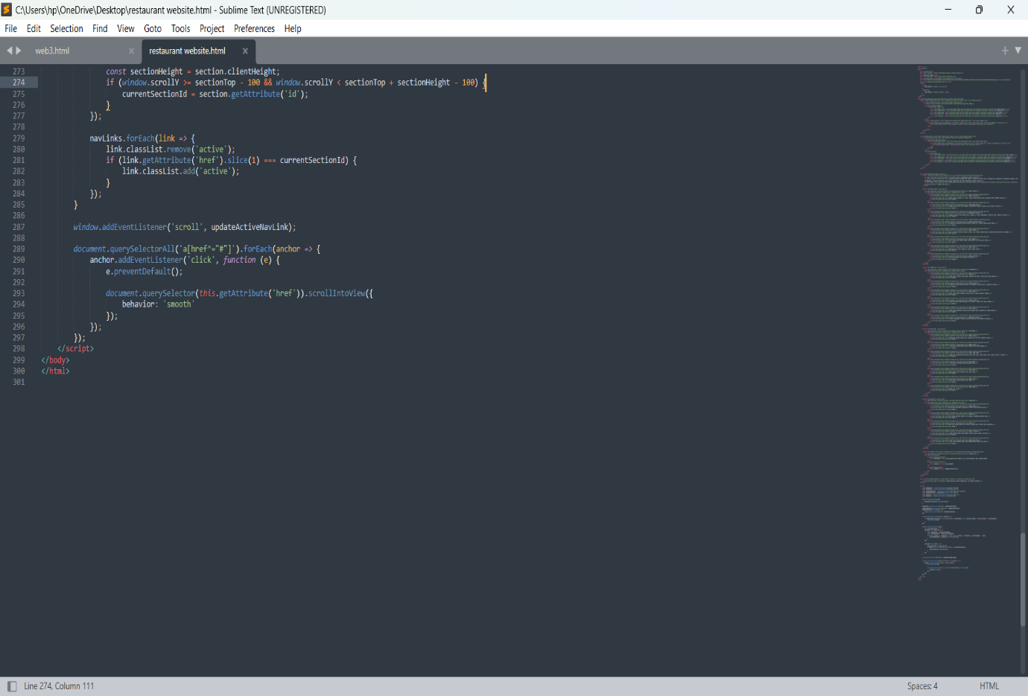

**Project Objective**

The objective of this project is to design and develop a modern, user-friendly, and responsive website for Spice of India that effectively showcases the restaurant’s brand, menu, and services. The website will aim to attract new customers, engage returning visitors, and streamline operations by offering key features such as menu browsing, contact information and integration with social media platforms. The end goal is to enhance the customer experience, boost online visibility, and increase both dine-in and takeout sales.

**Technologies Implemented**

**. HTML (HyperText Markup Language)**

* **Purpose**: The core structure of the website. It provides the content, headings, paragraphs, images, links, and other essential components.

**. CSS (Cascading Style Sheets)**

* **Purpose**: Controls the look and feel of the website, such as layout, colors, fonts, and responsiveness

**JavaScript**

* **Purpose**: Adds interactivity and dynamic features to the website.

**Project Features**

**1. Home Page**

* Brief introduction about the restaurant
* Call-to-action buttons (e.g., "View Menu", “Contact Us”)

**2. Menu Page**

* Categorized display of food and drinks (e.g. ,main course, bevenges, deserts)
* Prices listed clearly

**3.Contact Page**

* Embedded Google Map location
* Address, phone, email
* Contact form for inquiries or feedback

**4. Responsive Design**

* Fully functional across mobile, tablet, and desktop

**Development Process**

The development process of a restaurant website using HTML begins with planning the structure and content, including pages like Home, Menu, About, and Contact. After organizing a project folder, developers create the layout using HTML to structure the content such as navigation, images, text, and forms. CSS is then used to style the website, ensuring it looks attractive and fits the restaurant's brand. Optional JavaScript can be added for interactivity, such as reservation forms or image sliders. Finally, the website is tested for responsiveness and functionality across devices before being published online.

**Conclusion**

Creating a restaurant website using HTML is a foundational step in establishing an online presence for any dining business. By carefully planning the layout, building pages with clean HTML, enhancing design with CSS, and optionally adding interactivity with JavaScript, you can deliver a user-friendly and visually appealing website. A well-structured restaurant website not only attracts more customers but also provides essential information like menus, contact details, and location, helping the business grow and connect with its audience effectively.